Analysis of Building Frames (Using Kani’s Method)
Gasper Kani, a German engineer, developed another distribution procedure based on slope deflection equations. This method is very useful for the analysis of multistorey frames. The greatest advantage of this method is, even if a mistake is committed in distribution in one of the cycles, it converges finally to the correct answer. Even today, many practising engineers who are not familiar with computer methods, use Kani's method for the analysis of 3 to 4 storey building frames.
This method is first explained for structures with fixed ends. Then, the modifications to handle simply supported and overhanging ends are discussed. Analysis of symmetric frames making use of the symmetry is also explained, after which an analysis of general frames is taken up.

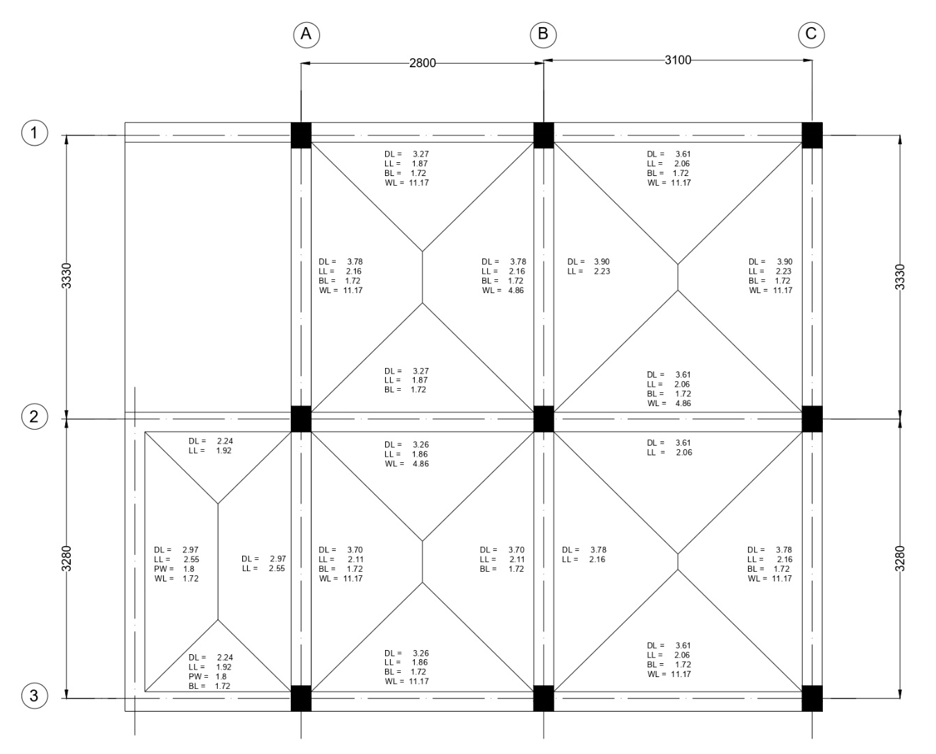
Figure 1: Beam Layout

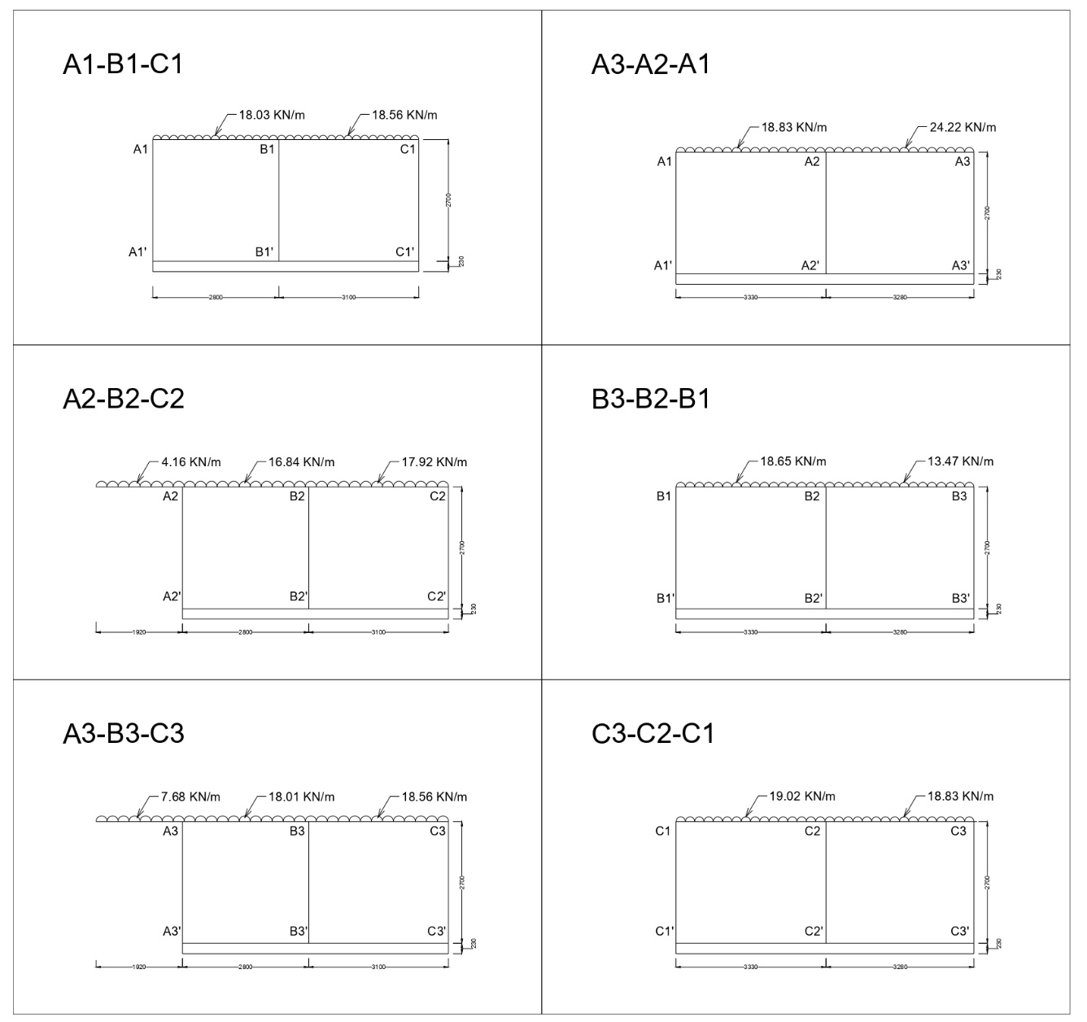
Figure 2: Frames.

Analysis of Frame A1-B1-C1

Step 1: Fixed End Moments
MF_{A1B1} = $\frac{-{WL}^{2}}{12}$ = $\frac{-18.03 × {2.8}^{2}}{12}$ = -11.78 KN-m
MF_{B1A1} = $\frac{{WL}^{2}}{12}$ = $\frac{18.03 × {2.8}^{2}}{12}$ = +11.78 KN-m
MF_{B1C1} = $\frac{-{WL}^{2}}{12}$ = $\frac{-18.56 × {3.1}^{2}}{12}$ = -14.86 KN-m
MF_{C1B1} = $\frac{{WL}^{2}}{12}$ = $\frac{18.56 × {3.1}^{2}}{12}$ = +14.86 KN-m
Fixed end moments in All the columns are zero.
i.e,
MF_{A1A1՛ =} MF_{A1՛A1} = MF_{B1B1՛ =} MF_{B1՛B1 =} MF_{C1C1՛ =} MF_{C1՛C1} = 0

Step 2: Rotation Factor $\left(R.F = -\frac{1}{2} \left(\frac{k}{Σk}\right) \right)$, $\left(k= \frac{4EI}{L}\right)$
Joints | Members | Stiffness ($k$) | $$Σk$$ | R.F
A1 | A1B1 | 1.428EI | 2.909EI | -0.245
A1 | A1A1՛ | 1.481EI | 2.909EI | -0.255
B1 | B1A1 | 1.428EI | 4.200EI | -0.170
B1 | B1C1 | 1.290EI | 4.200EI | -0.154
B1 | B1B1՛ | 1.481EI | 4.200EI | -0.176
C1 | C1B1 | 1.290EI | 2.771EI | -0.233
C1 | C1C1՛ | 1.481EI | 2.771EI | -0.267

Stiffness ($k$) $\left(k=\left(\frac{4EI}{L}\right)\right)$
K_{A1B1} = $\left(\frac{4EI}{2.8}\right)$ = 1.428EI
K_{A1A1՛} = $\left(\frac{4EI}{2.7}\right)$ = 1.481EI
K_{B1A1} = $\left(\frac{4EI}{2.8}\right)$ = 1.428EI
K_{B1C1} = $\left(\frac{4EI}{3.1}\right)$ = 1.290EI
K_{B1B1՛} = $\left(\frac{4EI}{2.7}\right)$ = 1.481EI
K_{C1B1} = $\left(\frac{4EI}{3.1}\right)$ = 1.290EI
K_{C1C1՛} = $\left(\frac{4EI}{2.7}\right)$ = 1.481EI
Sum of Stiffness ∑$k$ at Joints
A1: 1.428EI + 1.481EI = 2.909EI
B1: 1.428EI + 1.290EI + 1.481EI = 4.200EI
C1: 1.290EI + 1.481EI = 2.771EI
Rotation Factor $\left(R.F = -\frac{1}{2} \left(\frac{k}{Σk}\right) \right)$
R.F_{A1B1} = $-\frac{1}{2} \left(\frac{1.428EI}{2.909EI}\right)$ = -0.245
R.F_{A1A1՛} = $-\frac{1}{2} \left(\frac{1.481EI}{2.909EI}\right)$= -0.255
R.F_{B1A1} = $-\frac{1}{2} \left(\frac{1.428EI}{4.200EI}\right)$ = -0.170
R.F_{B1C1} = $-\frac{1}{2} \left(\frac{1.290EI}{4.200EI}\right)$ = -0.154
R.F_{B1B1՛} = $-\frac{1}{2} \left(\frac{1.481EI}{4.200EI}\right)$ = -0.176
R.F_{C1B1} = $-\frac{1}{2} \left(\frac{1.290EI}{2.771EI}\right)$ = -0.233
R.F_{C1C1՛} = $-\frac{1}{2} \left(\frac{1.481EI}{2.771EI}\right)$ = -0.267

Step 3: Displacement Factor $\left(D.F = -\frac{3}{2} \left(\frac{k}{Σk}\right) \right)$
Storey | Members | $$k$$ | $$Σk$$ | D.F
1 | A1A1՛ | 1.481EI | 4.444EI | -0.5
1 | B1B1՛ | 1.481EI | 4.444EI | -0.5
1 | C1C1՛ | 1.481EI | 4.444EI | -0.5

Stiffness ($k$) $\left(k=\left(\frac{4EI}{L}\right)\right)$
K_{A1A1՛} = $\left(\frac{4EI}{2.7}\right)$ = 1.481EI
K_{B1B1՛} = $\left(\frac{4EI}{2.7}\right)$ = 1.481EI
K_{C1C1՛} = $\left(\frac{4EI}{2.7}\right)$ = 1.481EI
Sum of Stiffness ∑$k$ at Storey
∑$k$ = 1.481EI + 1.481EI + 1.481EI = 4.444EI
Displacement Factor $\left(D.F = -\frac{3}{2} \left(\frac{k}{Σk}\right) \right)$
D.F_{A1A1՛} = $-\frac{3}{2} \left(\frac{1.481EI}{4.444EI}\right)$= -0.5
D.F_{B1B1՛} = $-\frac{3}{2} \left(\frac{1.481EI}{4.444EI}\right)$ = -0.5
D.F_{C1C1՛} = $-\frac{3}{2} \left(\frac{1.481EI}{4.444EI}\right)$ = -0.5

Rotation and Displacement Contribution

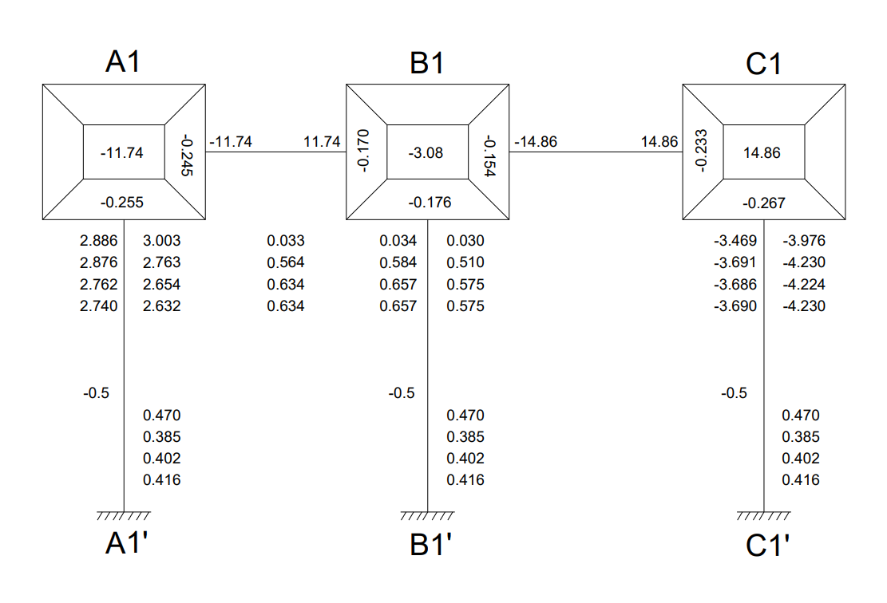

Cycle 1
Joint Rotation $\left(C.V. = R.F × \left[∑FEM+NCV+FCV\right]\right)$
M_{A1B1} = -0.245 × [-11.78 + 0 + 0] = 2.886
M_{A1A1՛} = -0.255 × [-11.78 + 0 + 0] = 3.003
M_{B1A1} = -0.170 × [-3.08 + 2.886 + 0] = 0.033
M_{B1C1} = -0.154 × [-3.08 + 2.886 + 0] = 0.030
M_{B1B1՛} = -0.176 × [-3.08 + 2.886 + 0] = 0.034
M_{C1B1} = -0.233 × [14.86 + 0.030 + 0] = -3.469
M_{C1C1՛} = -0.267 × [14.86 + 0.030 + 0] = -3.976

Displacement Contribution
For All Columns $\left(R.V. = D.F × \left[∑Rotations Contribution at Columns\right]\right)$
M_{A1A1՛} + M_{B1B1՛} + M_{C1C1՛} = -0.5 $×$ (3.003 + 0.034 + (-3.976)) = 0.470

Cycle 2
Joint Rotation $\left(C.V. = R.F × \left[∑FEM+NCV+FCV\right]\right)$
M_{A1B1} = -0.245 × [-11.78 + 0.470 + 0.033] = 2.763
M_{A1A1՛} = -0.255 × [-11.78 + 0.470 + 0.033] = 2.876
M_{B1A1} = -0.170 × [-3.08 + 0.470 + 2.763 + (-3.469)] = 0.564
M_{B1C1} = -0.154 × [-3.08 + 0.470 + 2.763 + (-3.469)] = 0.510
M_{B1B1՛} = -0.176 × [-3.08 + 0.470 + 2.763 + (-3.469)] = 0.584
M_{C1B1} = -0.233 × [14.86 + 0.470 + 0.510] = -3.691
M_{C1C1՛} = -0.267 × [14.86 + 0.470 + 0.510] = -4.230

Displacement Contribution
For All Columns $\left(R.V. = D.F × \left[∑Rotations Contribution at Columns\right]\right)$
M_{A1A1՛} + M_{B1B1՛} + M_{C1C1՛} = -0.5 $×$ (2.876 + 0.584 + (-4.230)) = 0.385

Cycle 3
Joint Rotation $\left(C.V. = R.F × \left[∑FEM+NCV+FCV\right]\right)$
M_{A1B1} = -0.245 × [-11.78 + 0.385 + 0.564] = 2.654
M_{A1A1՛} = -0.255 × [-11.78 + 0.385 + 0.564] = 2.762
M_{B1A1} = -0.170 × [-3.08 + 0.385 + 2.654 + (-3.691)] = 0.634
M_{B1C1} = -0.154 × [-3.08 + 0.385 + 2.654 + (-3.691)] = 0.575
M_{B1B1՛} = -0.176 × [-3.08 + 0.385 + 2.654 + (-3.691)] = 0.657
M_{C1B1} = -0.233 × [14.86 + 0.385 + 0.575] = -3.686
M_{C1C1՛} = -0.267 × [14.86 + 0.385 + 0.575] = -4.224

Displacement Contribution
For All Columns $\left(R.V. = D.F × \left[∑Rotations Contribution at Columns\right]\right)$
M_{A1A1՛} + M_{B1B1՛} + M_{C1C1՛} = -0.5 $×$ (2.762 + 0.657 + (-4.224)) = 0.4025

Cycle 4
Joint Rotation $\left(C.V. = R.F × \left[∑FEM+NCV+FCV\right]\right)$
M_{A1B1} = -0.245 × [-11.78 + 0.4025 + 0.634] = 2.632
M_{A1A1՛} = -0.255 × [-11.78 + 0.4025 + 0.634] = 2.740
M_{B1A1} = -0.170 × [-3.08 + 0.4025 + 2.632 + (-3.686)] = 0.634
M_{B1C1} = -0.154 × [-3.08 + 0.4025 + 2.632 + (-3.686)] = 0.575
M_{B1B1՛} = -0.176 × [-3.08 + 0.4025 + 2.632 + (-3.686)] = 0.657
M_{C1B1} = -0.233 × [14.86 + 0.4025 + 0.575] = -3.690
M_{C1C1՛} = -0.267 × [14.86 + 0.4025 + 0.575] = -4.230

Displacement Contribution
For All Columns $\left(R.V. = D.F × \left[∑Rotations Contribution at Columns\right]\right)$
M_{A1A1՛} + M_{B1B1՛} + M_{C1C1՛} = -0.5 $×$ (2.740 + 0.657 + (-4.230)) = 0.4165

Step 4: Final End Moments
M_{ij} = FEM + 2×M_{ij} (Near end Rotation) + M_{ji} (Far end Rotation) +M՛՛ (Displacement)

Beams (No Sway M՛՛= 0)
M_{A1B1} = -11.78 + 2(2.632) + 0.634 = -5.88
M_{B1A1} = 11.78 + 2(0.634) + 2.632 = 15.68
M_{B1C1} = -14.86+ 2(0.575) + (-3.690) = -17.40
M_{C1B1} = 14.86 + 2(-3.690) + 0.575 = 8.05

Column (With Sway M՛՛= 0.4165)
M_{A1A1՛} = 0 + 2(2.740) + 0 + 0.4165 = 5.89
M_{A1՛A1} = 0 + 2(0) + 2.740 + 0.4165 = 3.15
M_{B1B1՛} = 0 + 2(0.657) + 0 + 0.4165 = 1.73
M_{B1՛B1} = 0 + 2(0) + 0.657 + 0.4165 = 1.07
M_{C1C1՛} = 0 + 2(-4.230) + 0 + 0.4165 = -8.04
M_{C1՛C1} = 0 + 2(0) + (-4.230) + 0.4165 = -3.81

Equilibrium Check
Joint A1 = M_{A1B1} + M_{A1A1՛} = -5.88 + 5.89 = 0.01 ≈ 0
Joint A1 = M_{B1A1} + M_{B1C1՛ +} M_{B1B1՛} = 15.68 + (-17.40) + 1.73 = 0.01 ≈ 0
Joint A1 = M_{C1B1} + M_{C1C1՛} = 8.05 – 8.04 = 0.01 ≈ 0
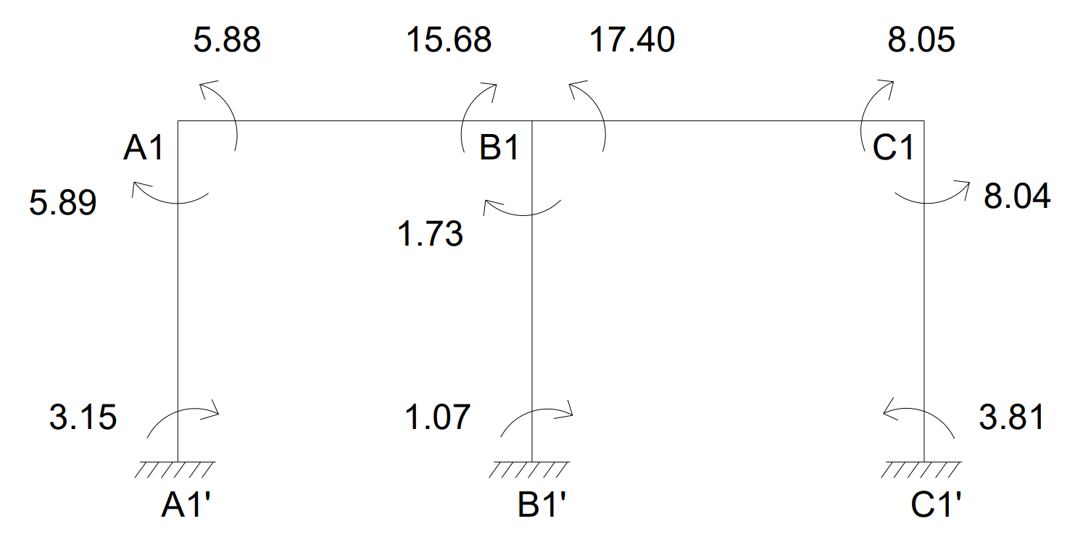

CALCULATION BENDING MOMENT
BM_{A1B1} = $\frac{{WL}^{2}}{8}$ = $\frac{{18.03 ×2.8}^{2}}{8}$ = 17.67KN-m
BM_{B1C1} = $\frac{{WL}^{2}}{8}$ = $\frac{{18.56 ×3.1}^{2}}{8}$ = 22.30KN-m
BENDING MOMENT DIAGRAM
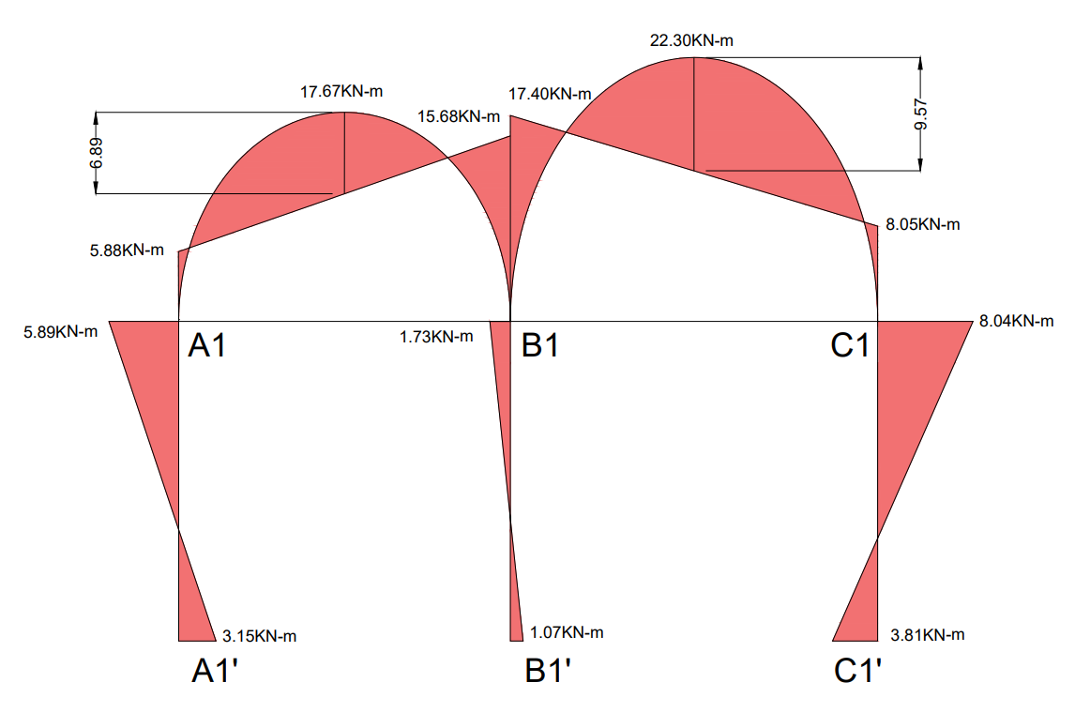

CALCULATION OF REACTIONS

SPAN A1-B1
Length (L) = 2.8m, UDL (W) = 18.03KN/m
Simply Supported Reactions:
R_{total} = $\frac{WL}{2}$ = $\frac{18.03 ×2.8}{2}$ = 25.24KN
Reaction Due to End Moments:
R_{moments} = $\frac{M_{B1A1}- M_{A1B1}}{L}$ = $\frac{15.68- 5.88}{2.8}$ = 3.50KN
Final Reactions:
R_{A1} = R_{total} – R_{moments} = 25.24 – 3.50 = 21.74KN
R_{B1(Left)} = R_{total} + R_{moments} = 25.24 + 3.50 = 28.74KN

SPAN B1-C1
Length (L) = 3.1m, UDL (W) = 18.56KN/m
Simply Supported Reactions:
R_{total} = $\frac{WL}{2}$ = $\frac{18.56 ×3.1}{2}$ = 28.77KN
Reaction Due to End Moments:
R_{moments} = $\frac{M_{B1C1}- M_{C1B1)}}{L}$ = $\frac{17.40- 8.05}{3.1}$ = 3.02KN
Final Reactions:
R_{B1(Right)} = R_{total} + R_{moments} = 28.77 + 3.02 = 31.79KN
R_{C1}= R_{total} – R_{moments} = 28.77 – 3.02 = 25.75KN
Total Reactions:
Reaction at Column A1 (R_{A1}) = 21.74KN
Reaction at Column B1 (R_{B1}) = R_{B1(Left)} + R_{B1(Right)} = 28.74 + 31.79 = 60.53KN
Reaction at Column C1 (R_{C1}) = 25.75KN
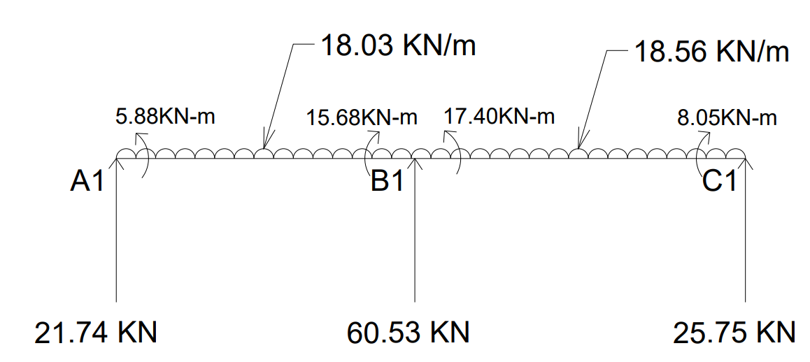
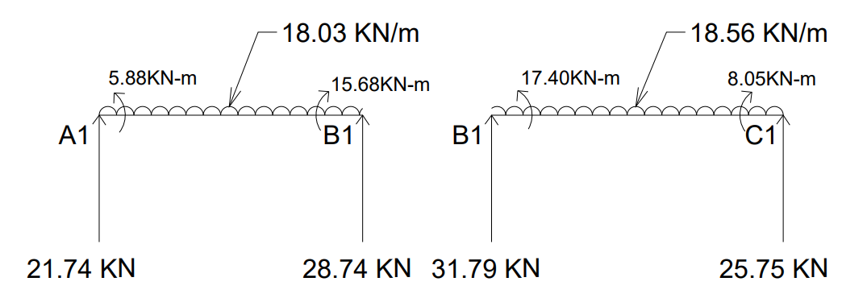

Shear Force:
At C1 = 25.75
At B1 = 25.75 - 18.56 × 3.1 = -31.79
= -31.79 + 60.53 = 28.74
At A1 = 25.75 + 60.53 – 18.56 × 3.1 – 18.03 × 2.8 = -21.74
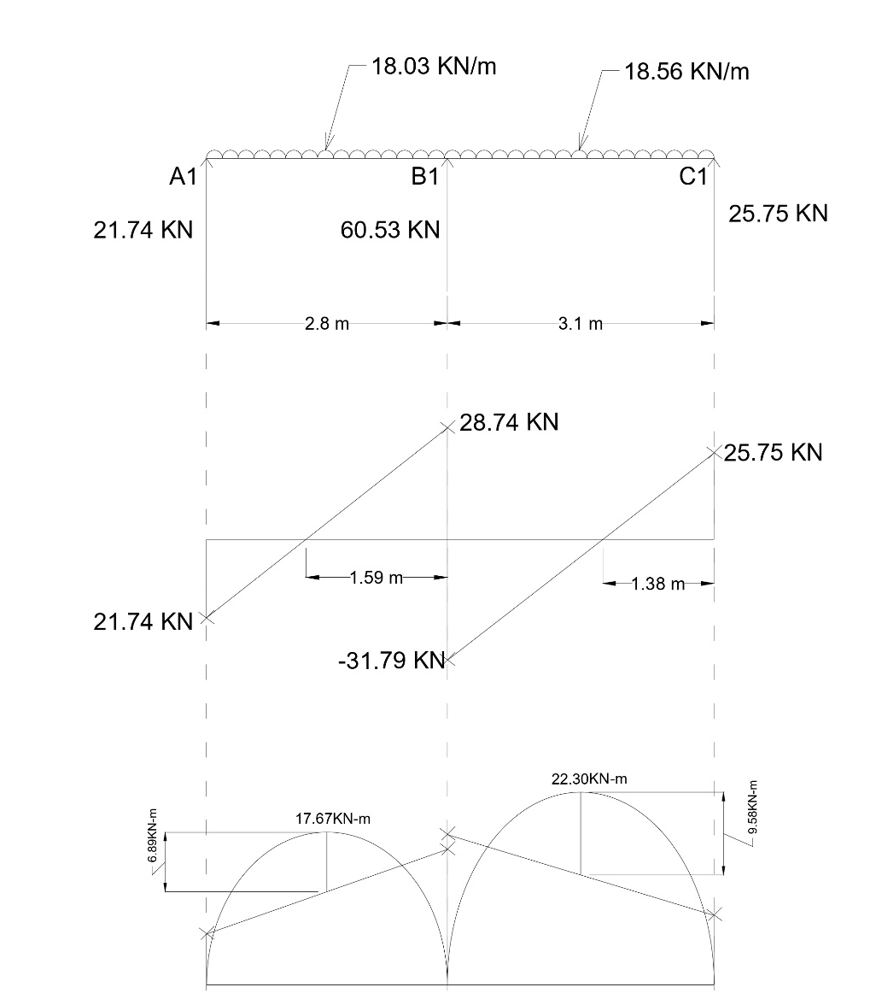

Analysis of Frame A2-B2-C2
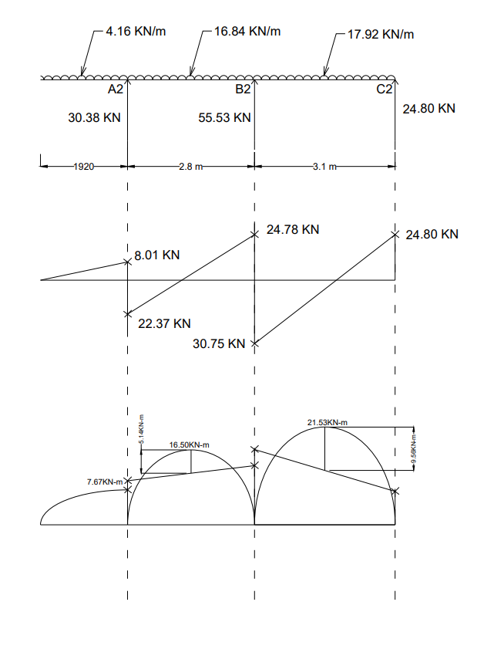

Analysis of Frame A3-B3-C3
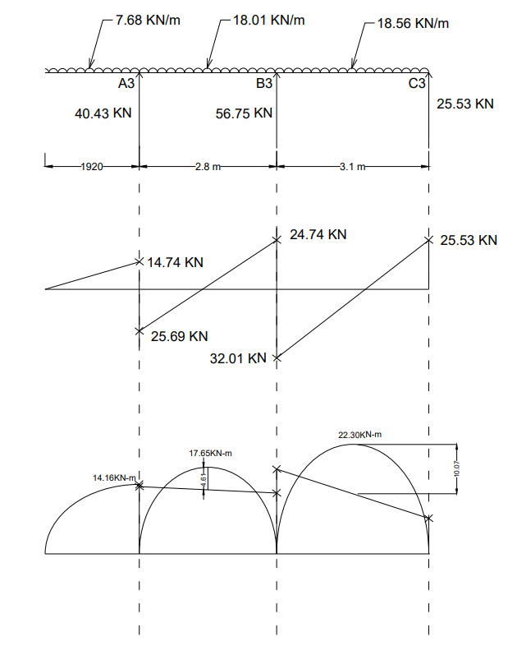

Analysis of Frame A1-A2-A3
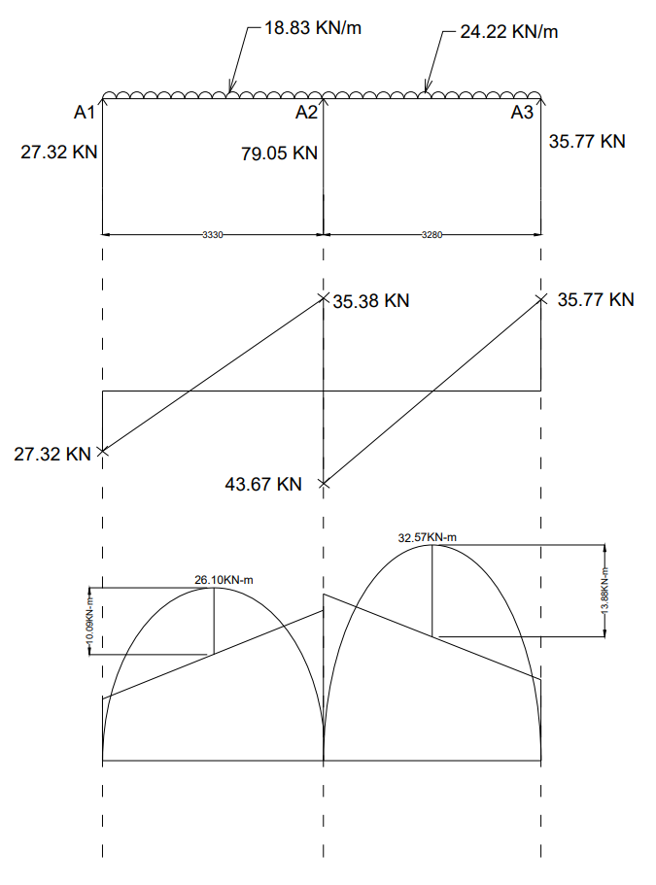
Analysis of Frame B1-B2-B3
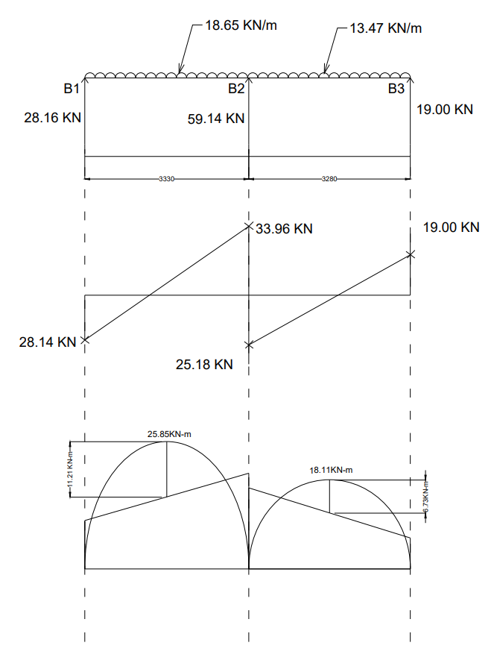

Analysis of Frame C1-C2-C3

